|  |  |
| --- | --- |
| **DOKUMENTASI EKSTERNAL**  External Documentation |  |
| **PROYEK**  ***Project*** |
| **COMP6051 – WEB PROGRAMMING**  ***Subject*** |
| SEMESTER GENAP 2017/2018 ***Even Semester Year 2017/2018*** |

## Judul Proyek

*Project**Title*

* GA.me

## Abstrak [50 – 200 words]

*Abstract*

* GA.me is a web-based game forum which accommodate users to share and read review about various games. GA.me is created using Bootstrap (for user interface), also Java Server Pages (JSP) and connected to MySQL database in order to make the web pages run dynamically. There are three types of user’s role in this website: admin, member, and guest (non-logged in user), which have different access permission to a spesific page.

## Pendahuluan

*Introduction*

* GA.me is a web-based game forum where users can share their review and also read other users’ review about various games. GA.me needs an application to accommodate user so they can create review to various games. There are three types of user’s role in this website:

1. Admin, who can manage user, game, game’s genre, and game’s developer.
2. Member, who can create and update their own game review.
3. Guest (Non-logged in user), who can only see other users’ review, unless they are logged in to the website.

* Here is the list of pages which can be accessed for each role:

|  |  |  |  |
| --- | --- | --- | --- |
|  | **Admin** | **Member** | **Guest** |
| **Home** | v | v | v |
| **Login** |  |  | v |
| **Register** |  |  | v |
| **Logout** | v | v |  |
| **Games** | Can post and update review | | Only read review |
| **Community** | v | v | v |
| **Edit Profile** |  | v |  |
| **Manage Game** | v |  |  |
| **Manage User** | v |  |  |
| **Manage Genre** | v |  |  |
| **Manage Developer** | v |  |  |

## Dokumentasi

*Report / Documentation*

* **HEADER (views/template/header.jsp)**
  + Left navigation menu contains link to home, games, and community page.
  + Right navigation menu will be shown differently for each user role:

1. **Guest (Non-logged in user)**
   * Only guest can access login and register page from navigation menu.



1. **Member**
   * Shows greeting to member.
   * Only member can access edit profile page from navigation menu.
   * Logout will destroy login session.

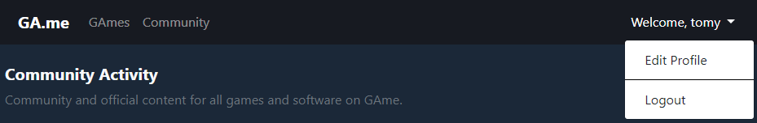

1. **Admin**
   * Shows greeting to admin.
   * Only admin can access manage game, user, genre, and developer page from navigation menu.
   * Logout will destroy login session.

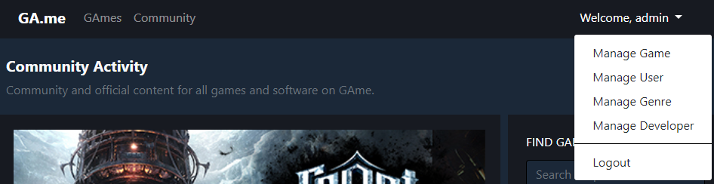

* **FOOTER (views/template/footer.jsp)**
  + Shows current date time and copyright symbol.



* **HOME (views/home.jsp)**
  + Game pictures are shown using slider.
  + Search box:
    - Search Game will redirect to games page and search game by its name.
    - Search User will redirect to community page and search user by its name.
  + Shows current user online count information.

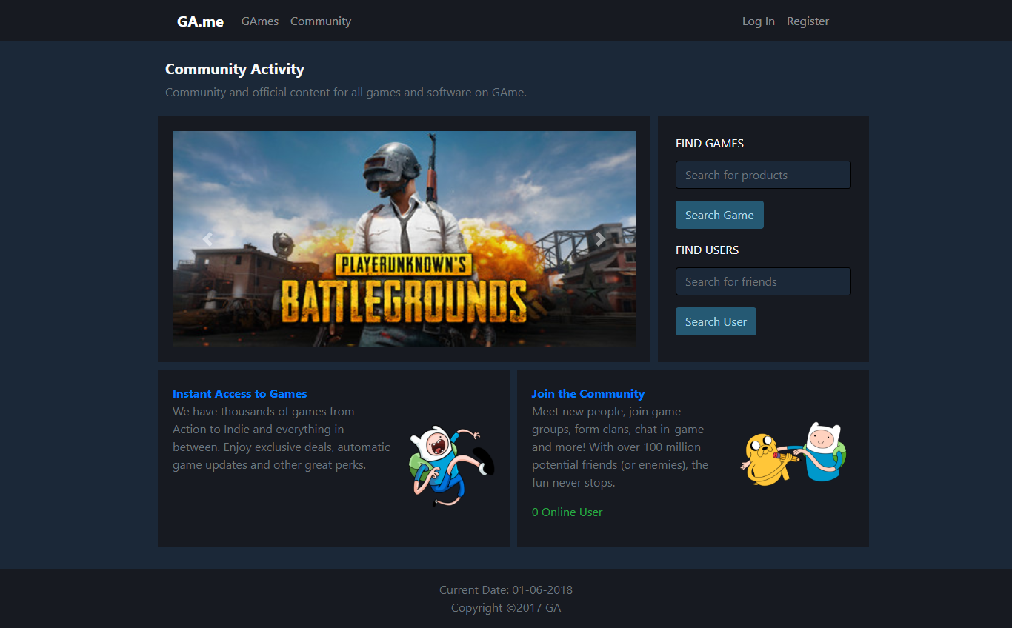

* **LOGIN (views/login.jsp)**
  + Only accessible to guest.

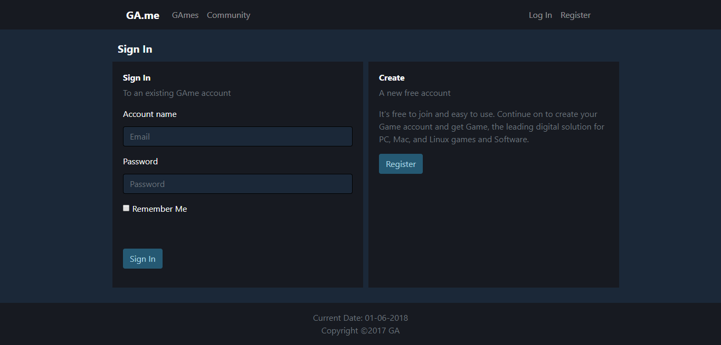

* + Display error message when email and password is incorrect.

|  |  |
| --- | --- |
| **Field** | **Information** |
| **Email** | * Must be **filled** and match with the data in the database |
| **Password** | * Must be **filled** and match with the data in the database |

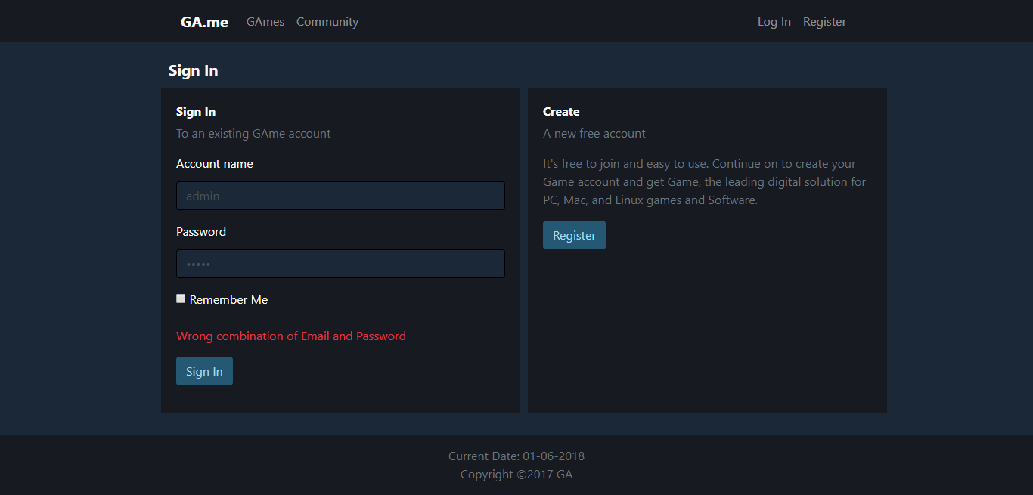

* + Will redirect to home page if login is success. Add current online user by 1.

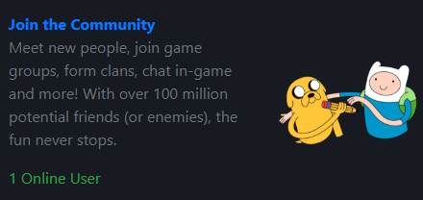

* + If the “Remember Me” is checked, then save username and password using cookies for 1 hour.

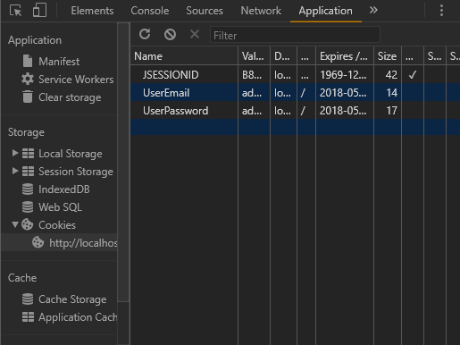

* **REGISTER (views/register.jsp)**
  + Only accessible to guest.

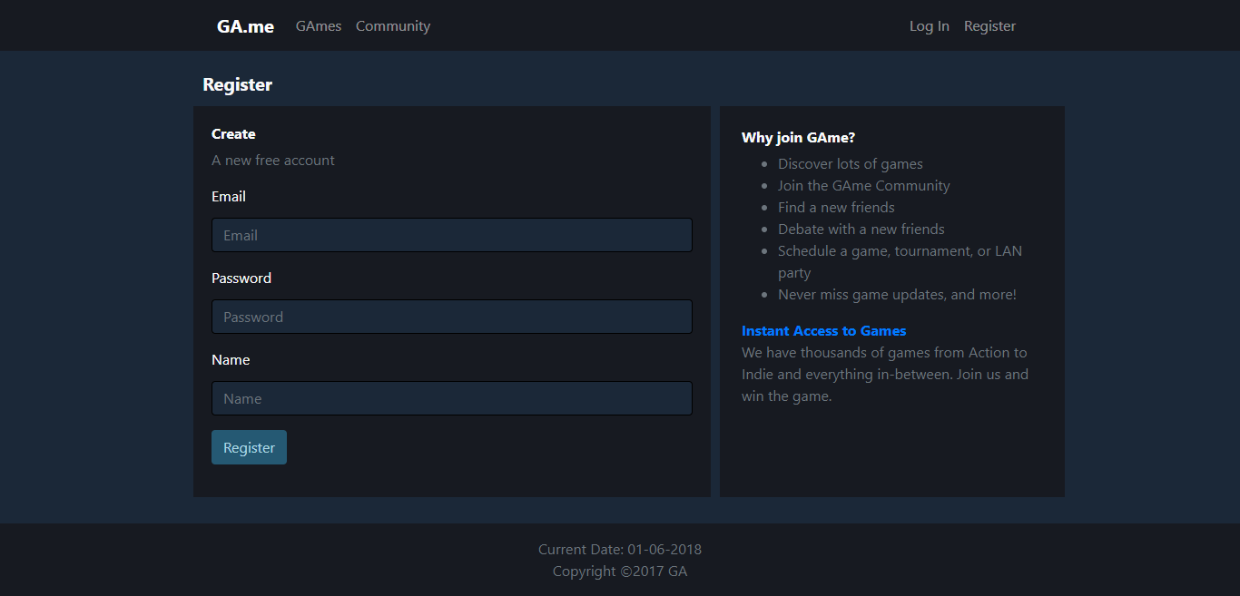

* + Display error message when user input incorrect data according to the validation.

|  |  |
| --- | --- |
| **Field** | **Information** |
| **Email** | * Must be filled * Length more than 4 characters * Email format: * Contain at(‘@’) and dot(‘.’) symbol * Contain only one at(‘@’) symbol * At(‘@’) and dot(‘.’) symbol must not be side by side   **Additional**: Email must not been registered before |
| **Password** | * Must be filled * Length must be more than 8 characters * Must contain symbol, letter, and number |
| **Name** | * Must be filled * Length must be between 5 and 20 characters * Must be alphabet |

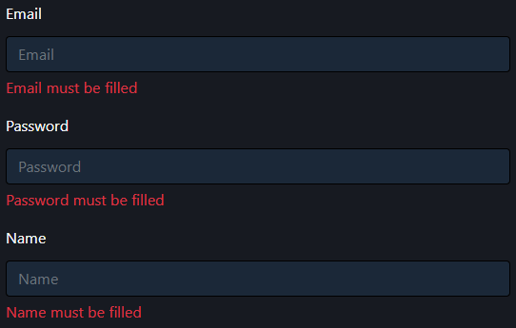

* + Will redirect to home page if register is success. Add current online user by 1.



* **GAMES (views/game.jsp)**
  + Accessible to all user role.
  + Search game by game title.
  + Displayed using pagination with 5 games for each page.
  + Clicking the game will redirect to game detail page.

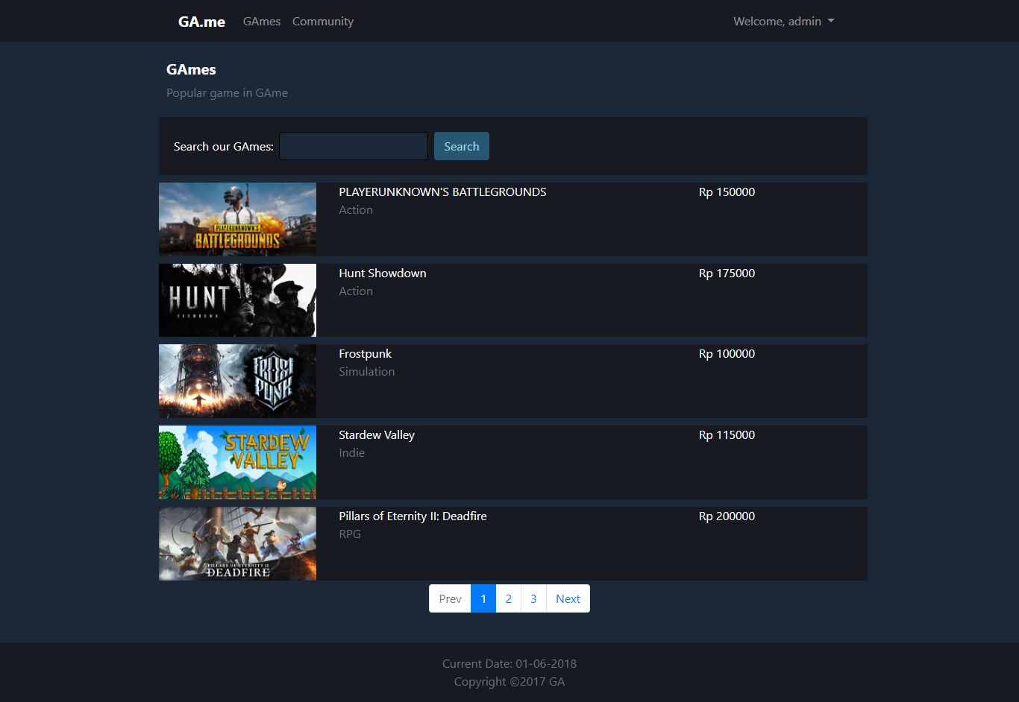

* **GAME DETAIL (views/gameDetail.jsp)**
  + Accessible to all user role, but only logged in users (admin and member) can post and update review.
  + Display error message when user input incorrect data according to the validation.

|  |  |
| --- | --- |
| **Field** | **Information** |
| **Review** | * Must be **filled** * Length must more than 10 characters |



* + Shows message when the game has no review yet.

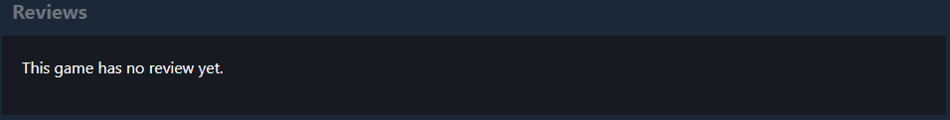

1. Guest (Non-logged in user)
   * Cannot post and update review, only read other’s review.

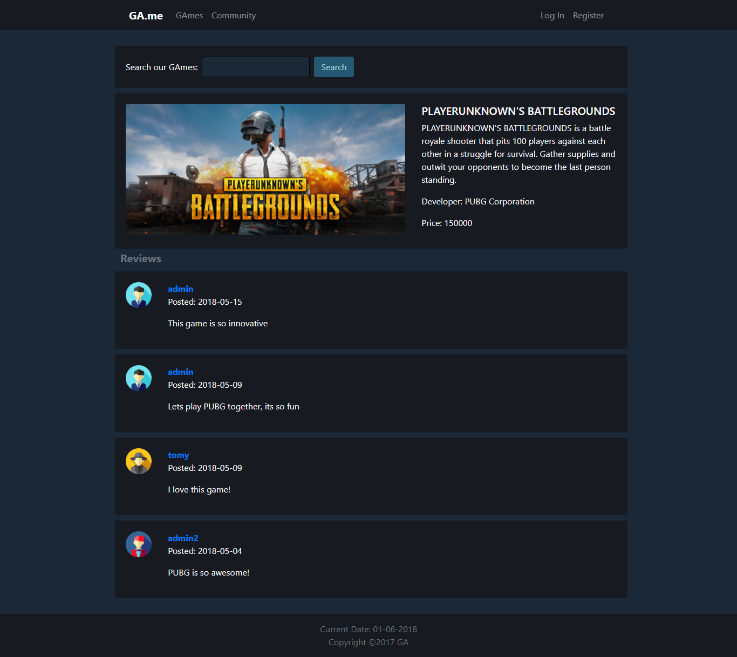

1. Admin and member (Logged in user)
   * Can post review more than once.
   * Can only update their own review, by clicking “Update Review” button.

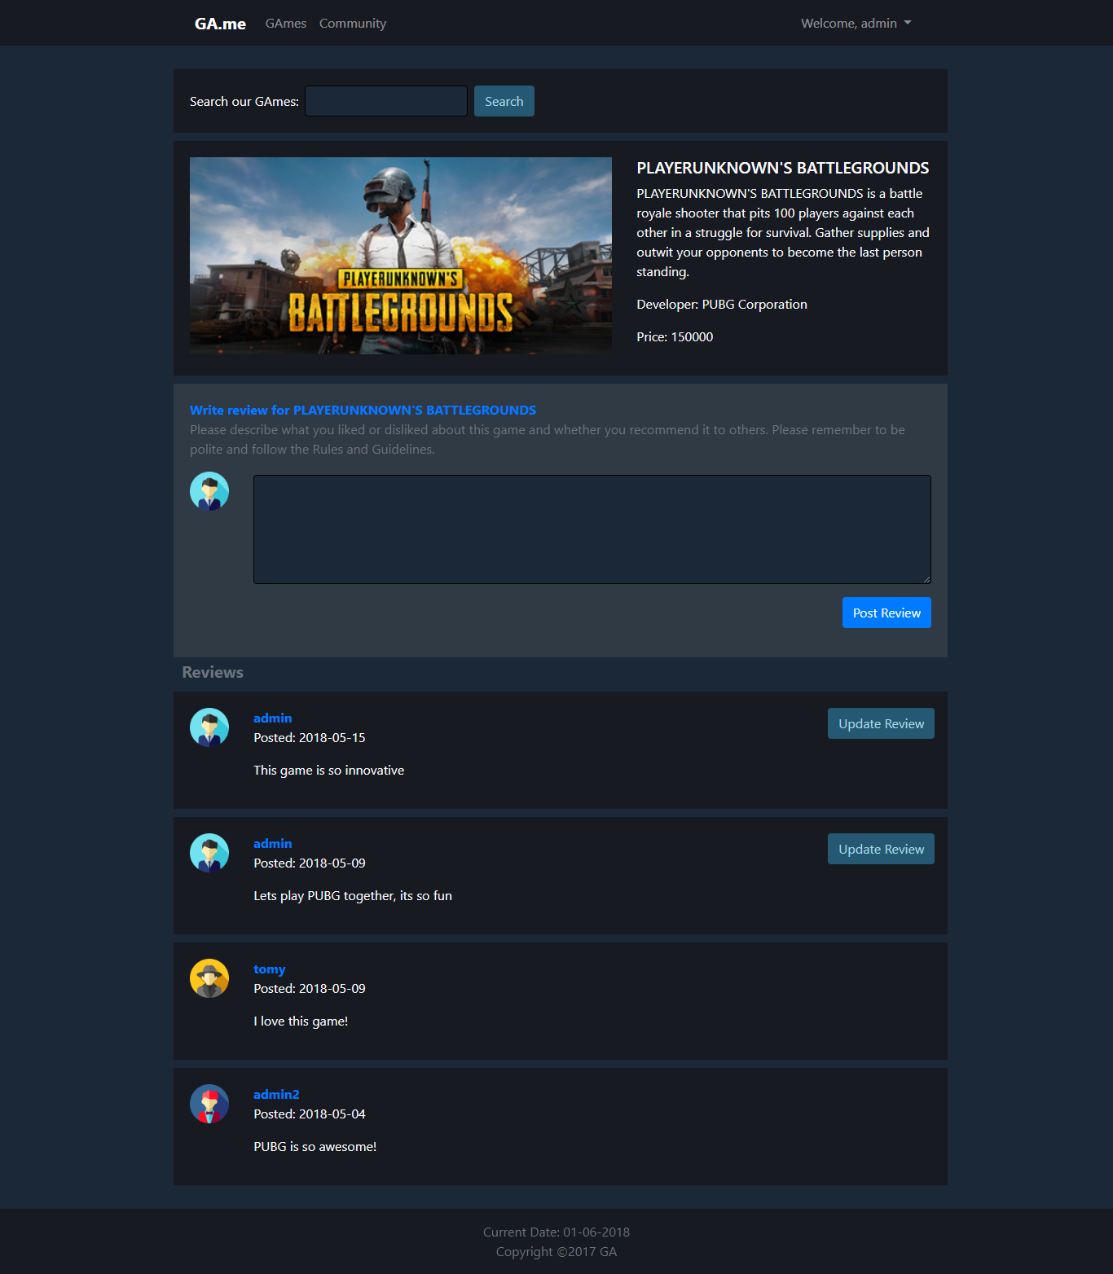

* **UPDATE REVIEW (views/updateReview.jsp)**
  + Only accessible by clicking the “Update Review” button on a specific review.

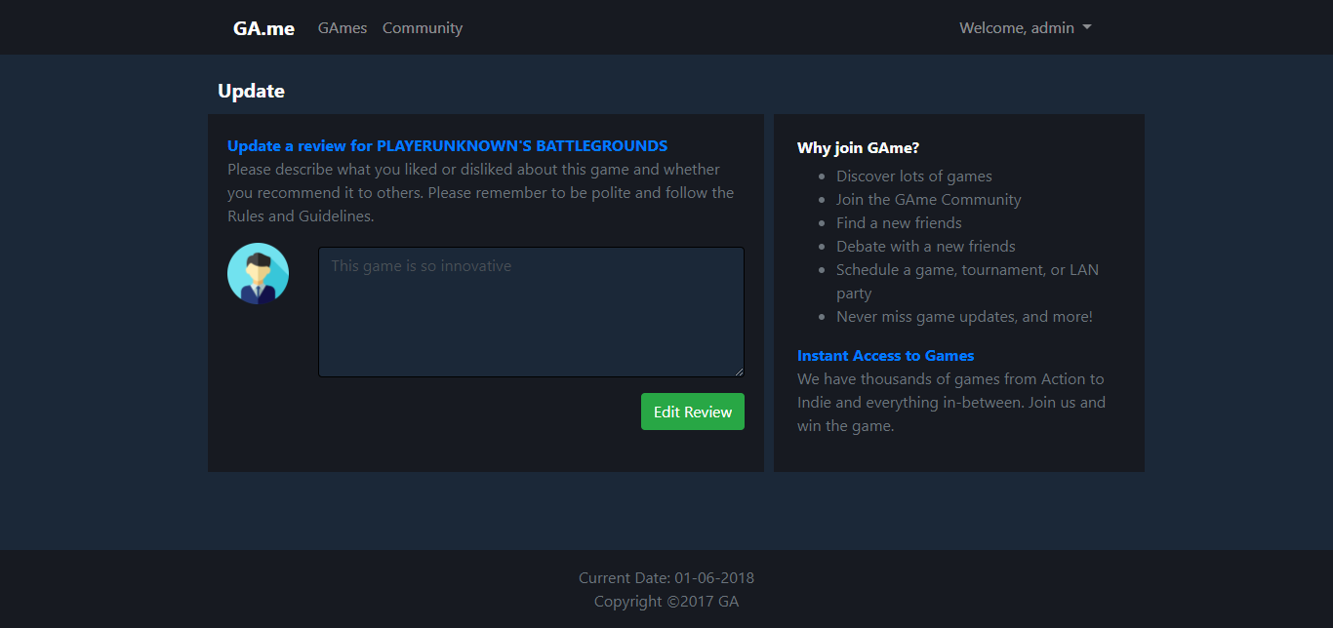

* + Display error message when user input incorrect data according to the validation.

|  |  |
| --- | --- |
| **Field** | **Information** |
| **Review** | * Must be **filled** * Length must more than 10 characters |



* **COMMUNITY (views/community.jsp)**
  + Accessible to all user role.
  + Search user by user name.
  + Displayed using pagination with 5 users for each page.

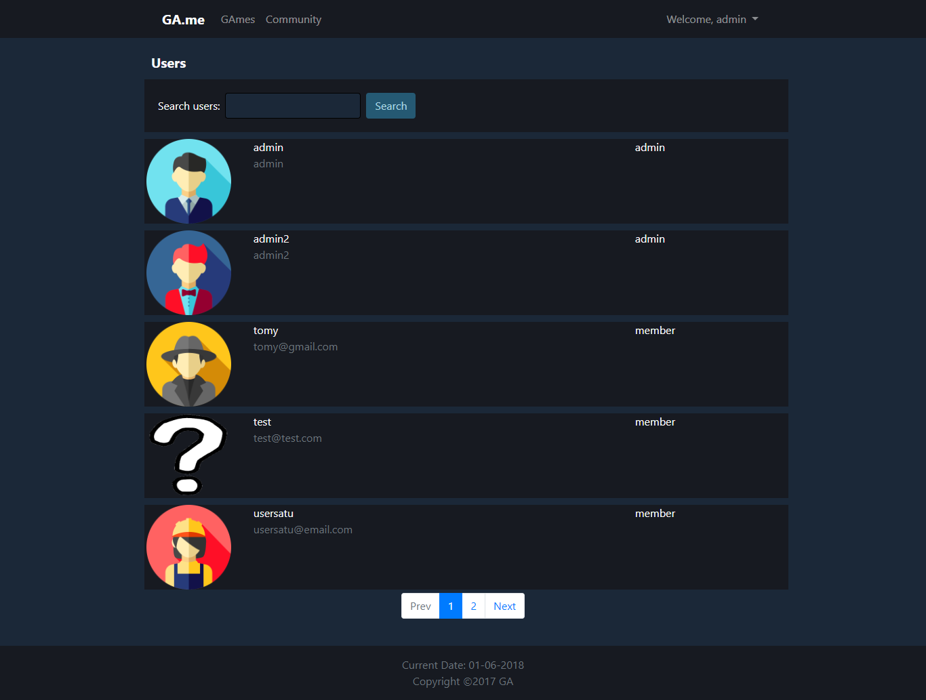

* **UPDATE PROFILE (views/updateProfile.jsp)**
  + Only accessible to member.

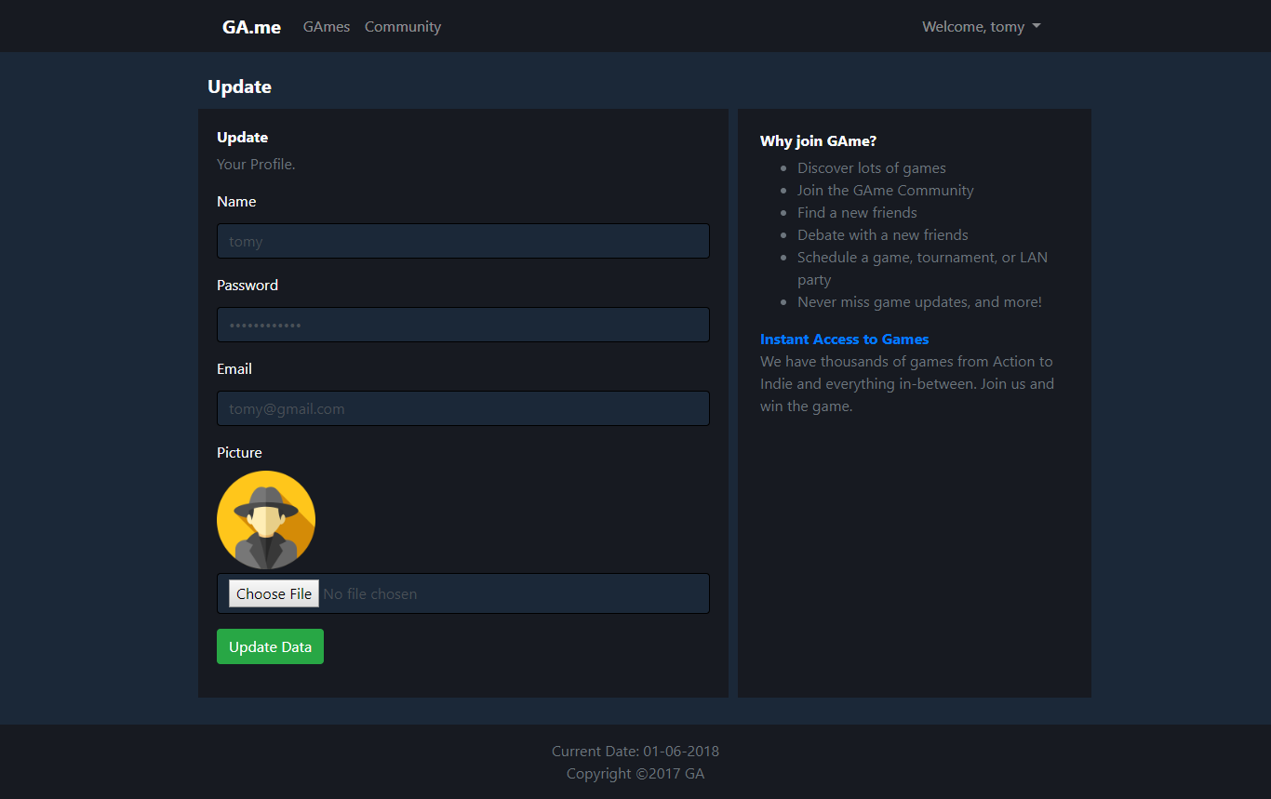

* + Display error message when user input incorrect data according to the validation.

|  |  |
| --- | --- |
| **Field** | **Information** |
| **Name** | * Must be filled * Length must be between 5 and 20 characters * Must be alphabet |
| **Password** | * Must be filled * Length must be more than 8 characters * Must contain symbol, letter, and number |
| **Email** | * Must be filled * Length more than 4 characters * Email format: * Contain at(‘@’) and dot(‘.’) symbol * Contain only one at(‘@’) symbol * At(‘@’) and dot(‘.’) symbol must not be side by side   **Additional**: Email must not been registered before |

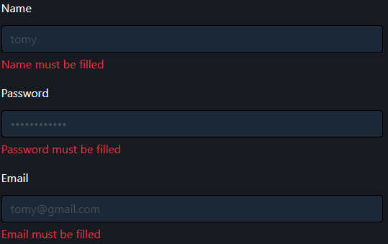

* **MANAGE GAME (views/admin/manageGame.jsp)**
  + Only accessible to admin.
  + Displayed using pagination with 6 games for each page.
  + Can perform:
    - Insert, by clicking “Insert New Game” button.
    - Update, by clicking “Update” button on a specific game.
    - Delete, by clicking “Delete” button on a specific game.

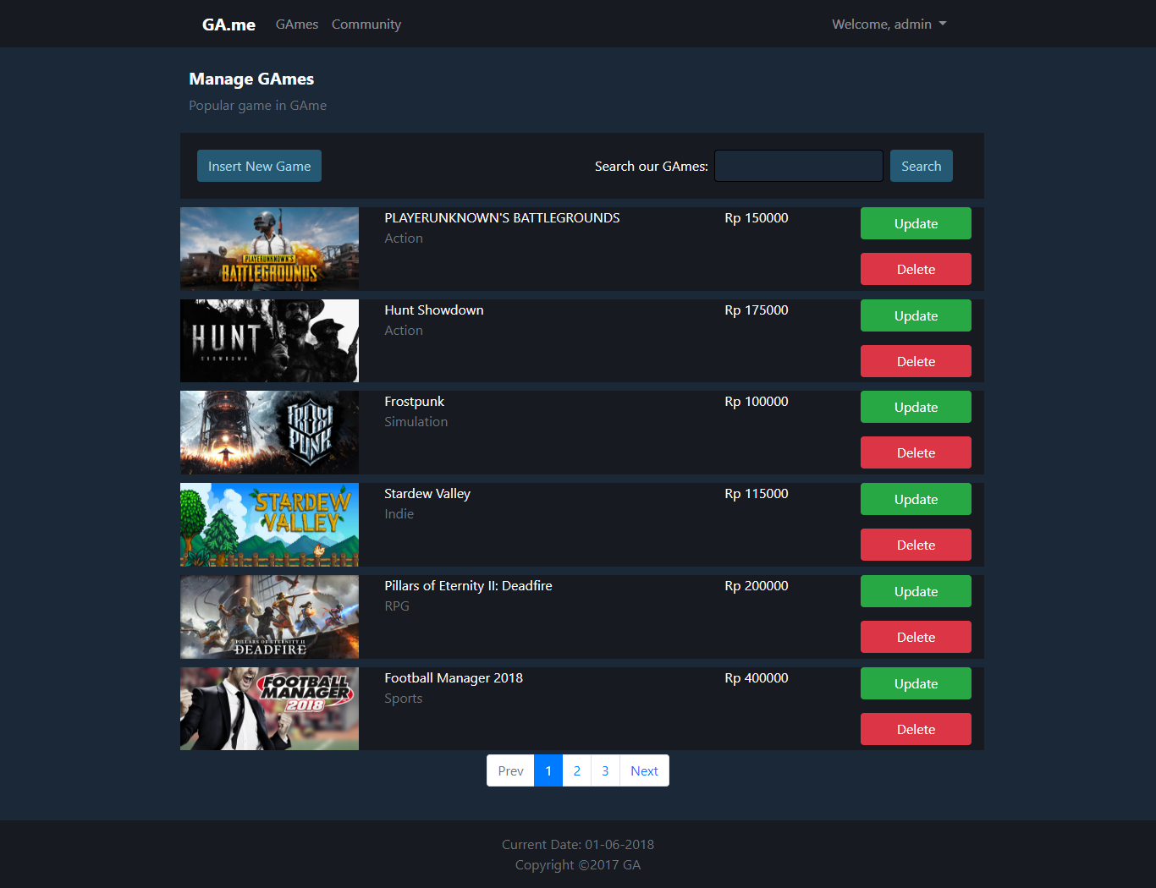

* + Clicking “Delete” button will trigger the modal to pop up.
    - Click “Yes” button will delete the selected game.
    - Click “No” or Close button will close the modal.

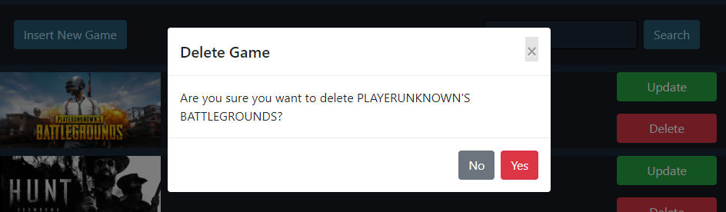

* **INSERT GAME (views/admin/insertGame.jsp)**
  + Only accessible to admin.

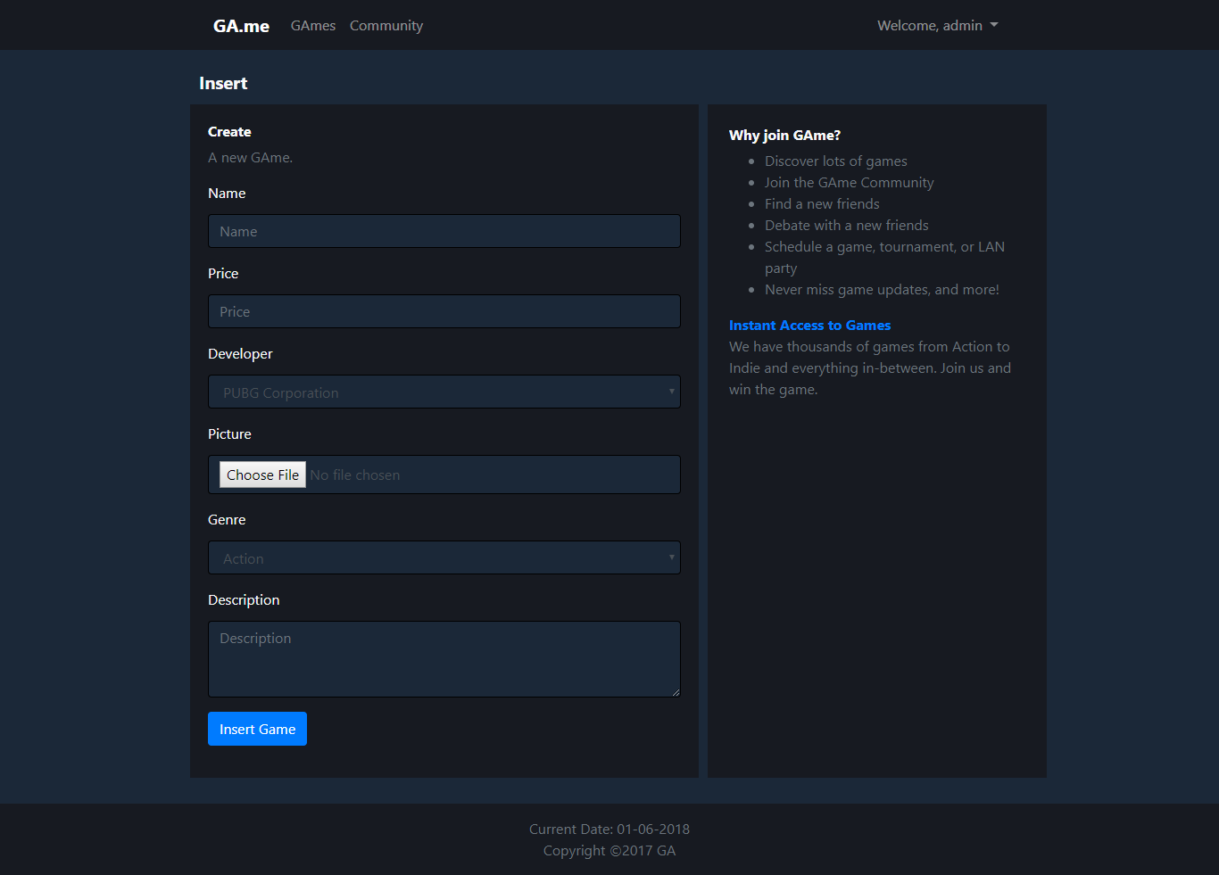

* + Display error message when user input incorrect data according to the validation.

|  |  |
| --- | --- |
| **Field** | **Information** |
| **Name** | * Must be filled * Length must be less than 50 characters |
| **Price** | * Must be filled * Must be numeric * Must be more than 0 |
| **Picture** | * Must be filled * File extension must be either .png or .jpg |
| **Description** | * Must be filled * Length must be less than 255 characters |

**Note**: Genre and Description are not validated because it is already guaranteed that admin can only select the existing data from database using dropdown (select option).

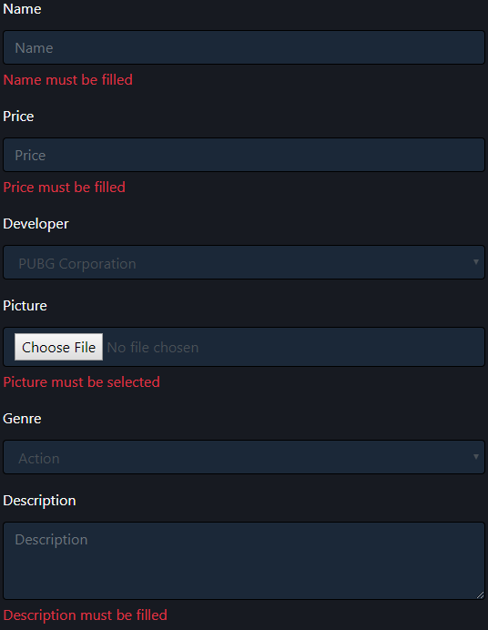

* **UPDATE GAME (views/admin/updateGame.jsp)**
  + Only accessible to admin.

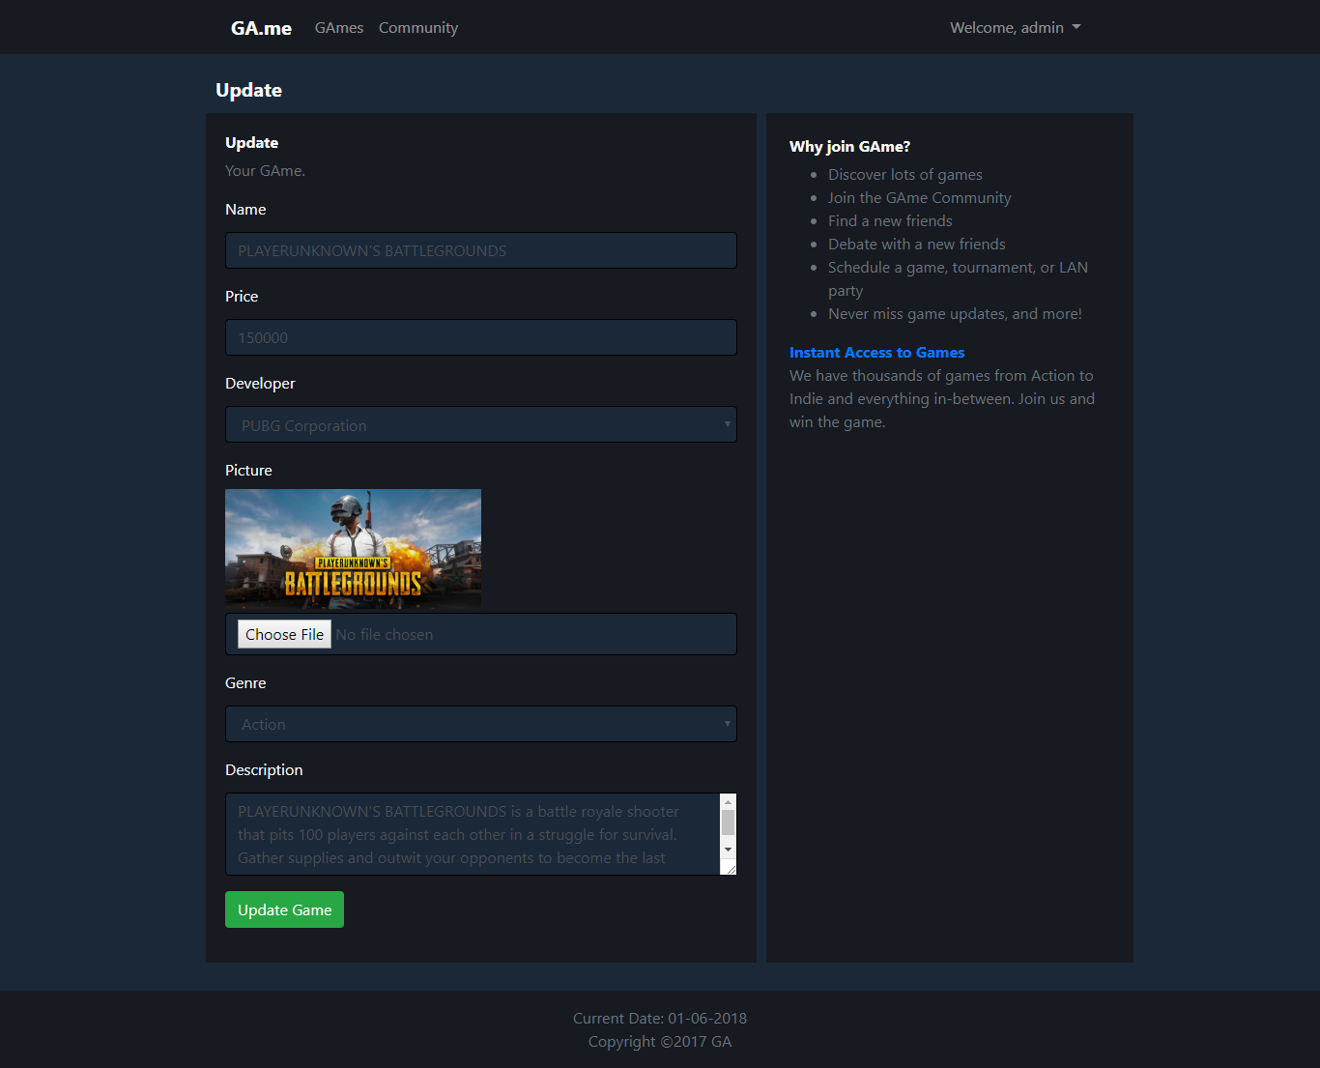

* + Display error message when user input incorrect data according to the validation.

|  |  |
| --- | --- |
| **Field** | **Information** |
| **Name** | * Must be filled * Length must be less than 50 characters |
| **Price** | * Must be filled * Must be numeric * Must be more than 0 |
| **Picture** | * Must be filled * File extension must be either .png or .jpg |
| **Description** | * Must be filled * Length must be less than 255 characters |

**Note**: Genre and Description are not validated because it is already guaranteed that admin can only select the existing data from database using dropdown (select option).

* **MANAGE USER (views/admin/manageUser.jsp)**
  + Only accessible to admin.
  + Displayed using pagination with 6 members (excluding admin) for each page.
  + Can only perform Delete, by clicking “Delete” button on a specific user.

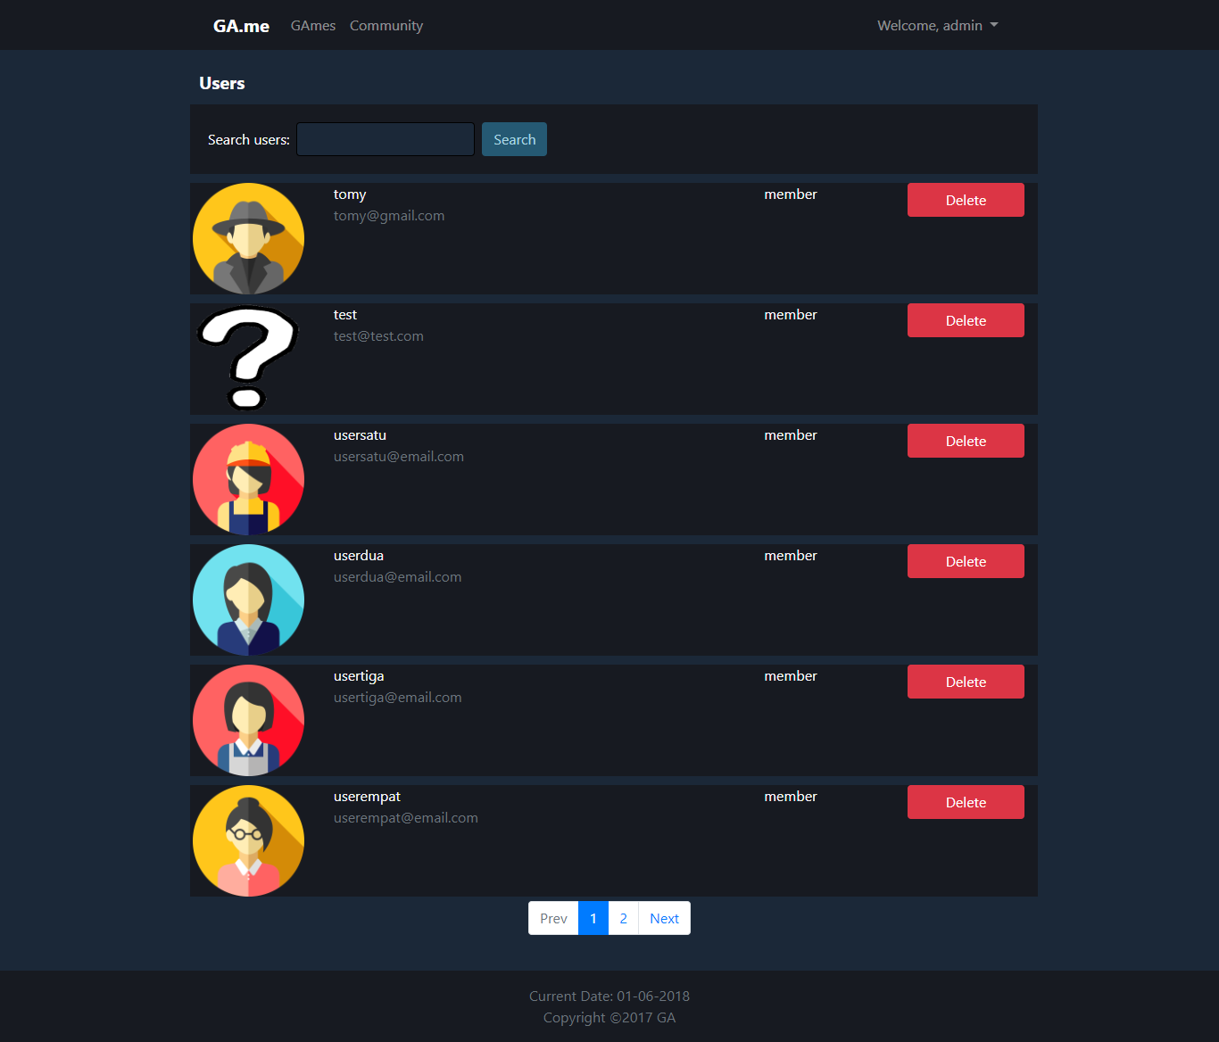

* + Clicking “Delete” button will trigger the modal to pop up.
    - Click “Yes” button will delete the selected user.
    - Click “No” or Close button will close the modal.

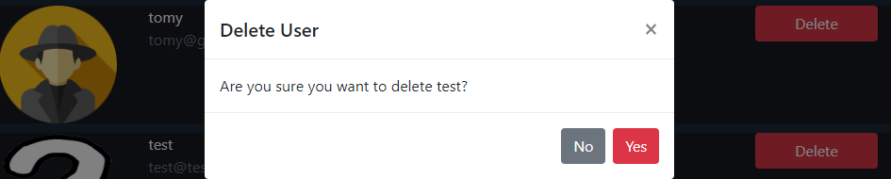

* **MANAGE GENRE (views/admin/manageGenre.jsp)**
  + Only accessible to admin.
  + Displayed using pagination with 6 genres for each page.
  + Can perform:
    - Insert, by clicking “Insert New Genre” button.
    - Update, by clicking “Update” button on a specific genre.
    - Delete, by clicking “Delete” button on a specific genre.

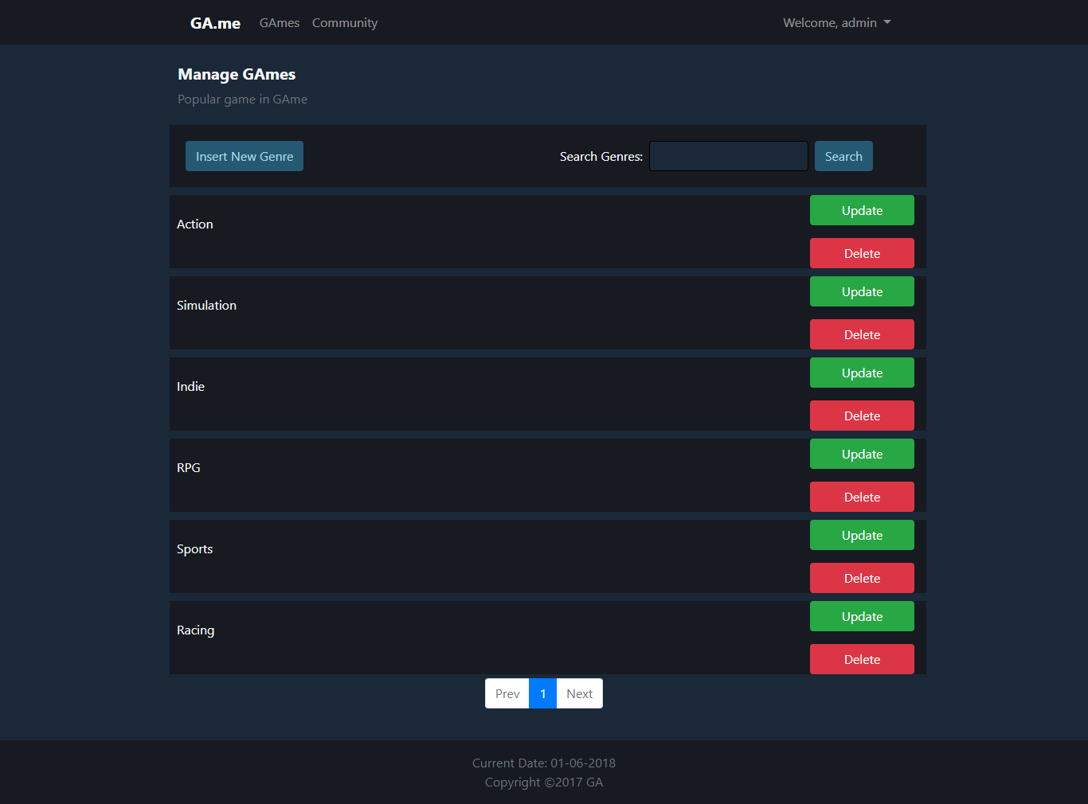

* + Clicking “Delete” button will trigger the modal to pop up.
    - Click “Yes” button will delete the selected genre.
    - Click “No” or Close button will close the modal.

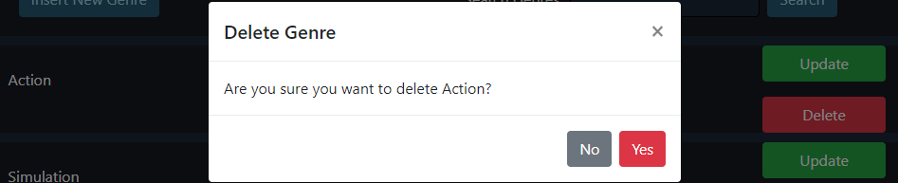

* + Game with deleted genre will be displayed as “No Genre” in the list.

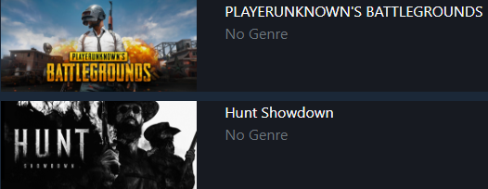

* **INSERT GENRE (views/admin/insertGenre.jsp)**
  + Only accessible to admin.

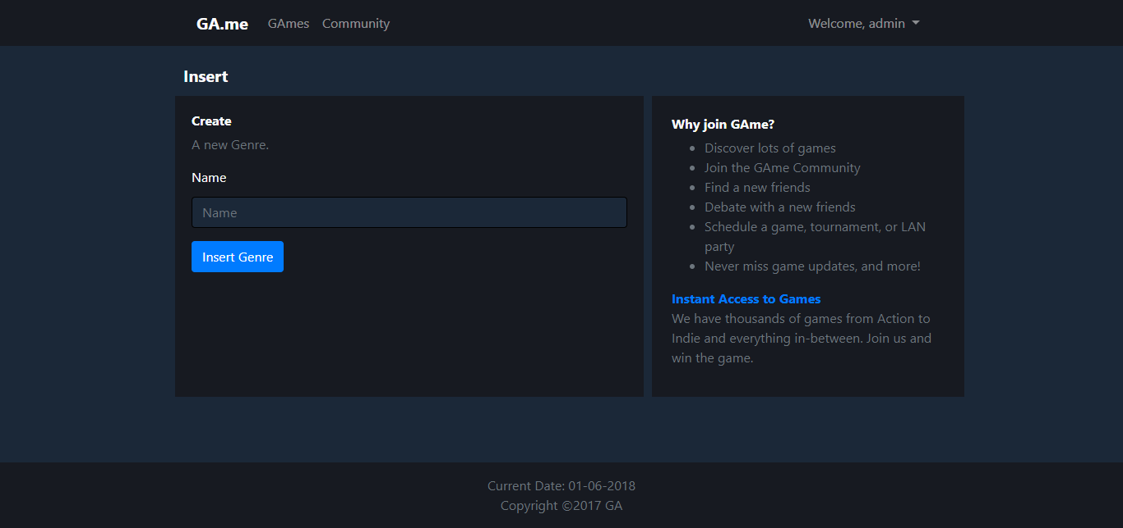

* + Display error message when user input incorrect data according to the validation.

|  |  |
| --- | --- |
| **Field** | **Information** |
| **Genre** | * Must be **filled** * Length must less than 20 characters |

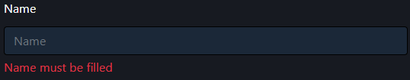

* **UPDATE GENRE (views/admin/updateGenre.jsp)**
  + Only accessible to admin.

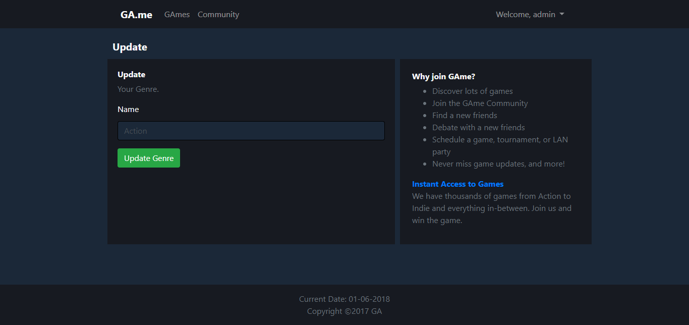

* + Display error message when user input incorrect data according to the validation.

|  |  |
| --- | --- |
| **Field** | **Information** |
| **Genre** | * Must be **filled** * Length must less than 20 characters |



* **MANAGE DEVELOPER (views/admin/manageDeveloper.jsp)**
  + Only accessible to admin.
  + Displayed using pagination with 6 developers for each page.
  + Can perform:
    - Insert, by clicking “Insert New Game” button.
    - Update, by clicking “Update” button on a specific developer.
    - Delete, by clicking “Delete” button on a specific developer.

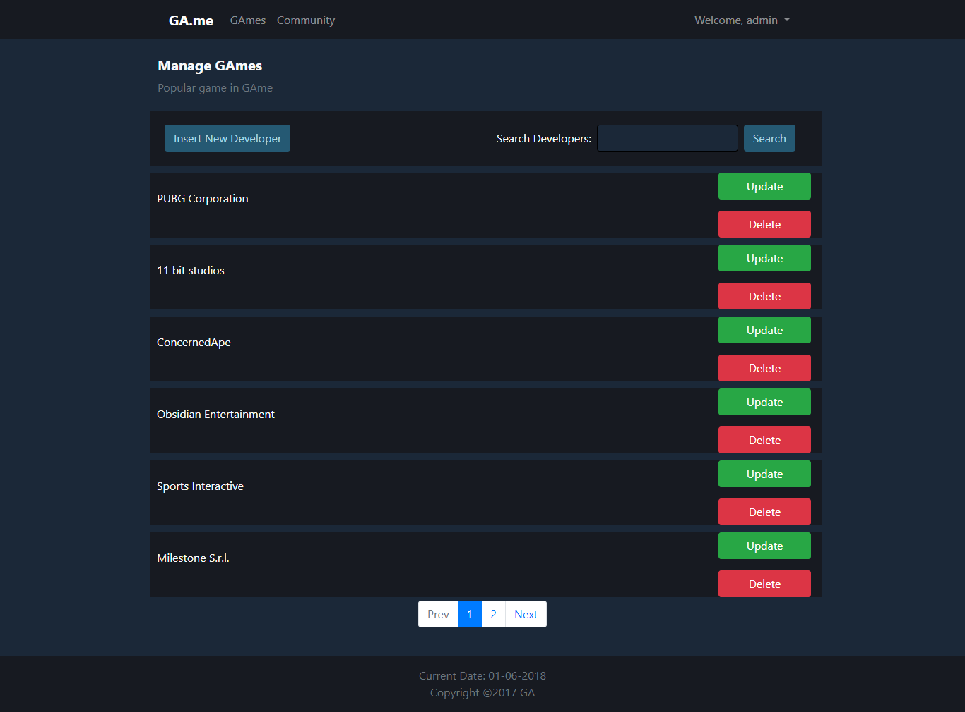

* + Clicking “Delete” button will trigger the modal to pop up.
    - Click “Yes” button will delete the selected developer.
    - Click “No” or Close button will close the modal.

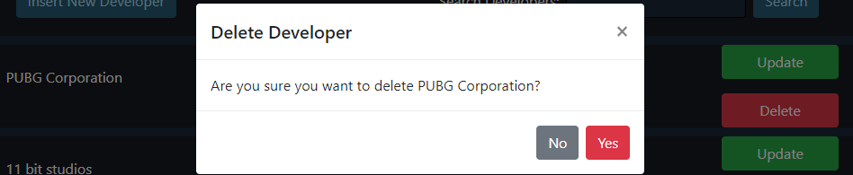

* + Game with deleted developer will be displayed as “No Developer” in the description.

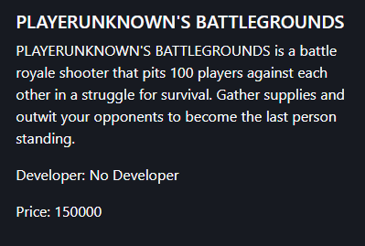

* **INSERT DEVELOPER (views/admin/insertDeveloper.jsp)**
  + Only accessible to admin.

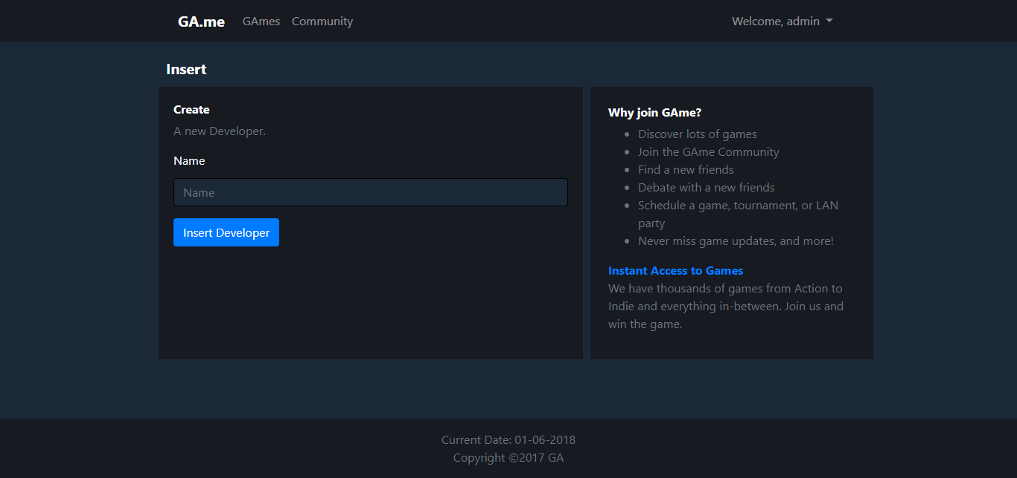

* + Display error message when user input incorrect data according to the validation.

|  |  |
| --- | --- |
| **Field** | **Information** |
| **Developer** | * Must be **filled** * Length must less than 20 characters |



* **UPDATE DEVELOPER (views/admin/updateDeveloper.jsp)**
  + Only accessible to admin.

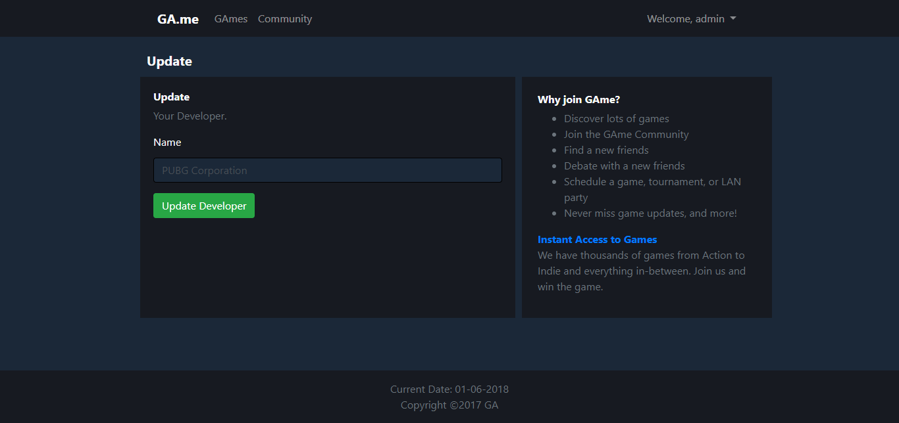

* + Display error message when user input incorrect data according to the validation.

|  |  |
| --- | --- |
| **Field** | **Information** |
| **Developer** | * Must be **filled** * Length must less than 20 characters |



* **BAD URL PAGE (views/template/badUrl.jsp)**
  + User will be redirected to this page if they are not allowed to access the page. Some action that will trigger this page:
    - Logged in user try to access login and register page.
    - Guest or admin try to access update profile page.
    - Logged in user try to access update review page directly from the link.
    - Guest or member try to access admin page.
    - Admin try to access update game, genre, and developer directly from the link.

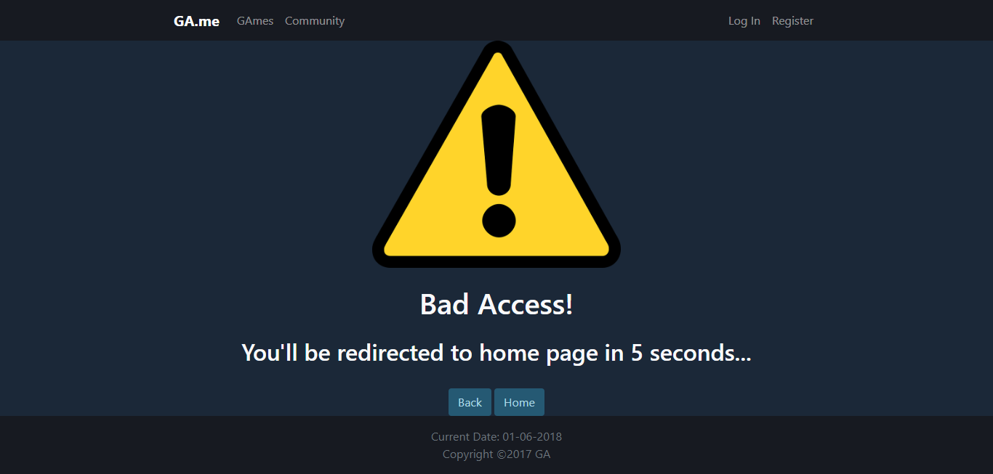

* + User will be automatically redirected to home page after 5 seconds.
  + Click “Back” button to redirect user to previous page.
  + Click “Home” button to redirect user to home page.

## Referensi

*References*

* **BOOTSTRAP (CSS & JS)**
  + https://getbootstrap.com/
* **GAMEPICTURES (AND DESCRIPTION)**
  + https://store.steampowered.com/app/427520/Factorio/
  + https://store.steampowered.com/app/611660/Fallout_4_VR/
  + https://store.steampowered.com/app/588430/Fallout_Shelter/
  + https://store.steampowered.com/app/595520/FINAL_FANTASY_XII_THE_ZODIAC_AGE/
  + https://store.steampowered.com/app/637650/FINAL_FANTASY_XV_WINDOWS_EDITION/
  + https://store.steampowered.com/app/624090/Football_Manager_2018/
  + https://store.steampowered.com/app/323190/Frostpunk/
  + https://store.steampowered.com/app/4000/Garrys_Mod/
  + https://store.steampowered.com/app/594650/Hunt_Showdown/
  + https://store.steampowered.com/app/560130/Pillars_of_Eternity_II_Deadfire/
  + https://store.steampowered.com/app/578080/PLAYERUNKNOWNS_BATTLEGROUNDS/
  + https://store.steampowered.com/app/477770/Ride_2/
  + https://store.steampowered.com/app/294100/RimWorld/
  + https://store.steampowered.com/app/413150/Stardew_Valley/
  + https://store.steampowered.com/app/611670/The_Elder_Scrolls_V_Skyrim_VR/
* **MISC**
  + http://www.pngmart.com/image/54896
  + http://www.pngmart.com/image/54800
  + https://pixabay.com/en/warning-yellow-attention-147699/
* **USERPICTURES**
  + https://www.flaticon.com/free-icon/businessman_206853
  + https://www.flaticon.com/free-icon/croupier_206862
  + https://icons8.com/icon/645/help
  + https://www.flaticon.com/free-icon/detective_206858
  + https://www.flaticon.com/free-icon/loader_206878
  + https://www.flaticon.com/free-icon/maid_206861
  + https://www.flaticon.com/free-icon/manager_206864
  + https://www.flaticon.com/free-icon/showman_206863
  + https://www.flaticon.com/free-icon/teacher_206897
  + https://www.flaticon.com/free-icon/waiter_206872
  + https://www.flaticon.com/free-icon/worker_206870

Disiapkan Oleh,

*Prepared by,*

* **1801431662 - Tomy**